**EXPERIMENT 2**

**Nmap Scan**

**Aim:**

To install and perform Nmap scan (note :- you may use ip address or website name)

**Procedure:**

Step 1: Open Nmap from Kali Linux (Goto Applications->select Information Gathering>select

Nmap)

Step 2: Perform different types of scan

(Tcp, Udp, Ack, Syn, Fin, Null, Xmas, Rpc, Idle)- scan types

**Scanning Techniques**

**Flag Use Example**

**-sS TCP syn port scan nmap -sS 192.168.1.1**

**-sT TCP connect port scan nmap -sT 192.168.1.1**

**–sU UDP port scan nmap –sU 192.168.1.1**

**–sA TCP ack port scan nmap –sA 192.168.1.1**

# Step 3:-

To perform host discovery

|  |  |  |
| --- | --- | --- |
| -Pn | only port scan | nmap -Pn192.168.1.1 |
| -sn | only host discover | nmap -sn192.168.1.1 |
| -PR | arp discovery on a local network | nmap -PR192.168.1.1 |
| -n | disable DNS resolution | nmap -n 192.168.1.1 |

Step4 PORT SPECIFICATION

|  |  |  |
| --- | --- | --- |
| **Flag** | **Use** | **Use** |
| **-p** | **specify a port or port**  **range** | **nmap -p 1-30 192.168.1.1** |
| **-p-** | **scan all ports** | **nmap -p- 192.168.1.1** |
| **F** | **fast port scan** | **nmap -F 192.168.1.1** |

# Step 5:-

**Service Version and OS Detection**

Flag Use Example

|  |  |  |
| --- | --- | --- |
| -sV | detect the version of services running | nmap -sV 192.168.1.1 |
| -A | aggressive scan | nmap -A 192.168.1.1 |
| -O | detect operating system of the target | nmap -O 192.168.1.1 |

# Step 6:-

**Timing and Performance**

Flag Use Example

|  |  |  |
| --- | --- | --- |
| -T0 | paranoid IDS evasion | nmap -T0 192.168.1.1 |
| -T1 | sneaky IDS evasion | nmap -T1 192.168.1.1 |
| -T2 | polite IDS evasion | nmap -T2 192.168.1.1 |
| -T3 | normal IDS evasion | nmap -T3 192.168.1.1 |
| -T4 | aggressive speed scan | nmap -T4 192.168.1.1 |
| -T5 | insane speed scan | nmap -T5 192.168.1.1 |

OUTPUT:

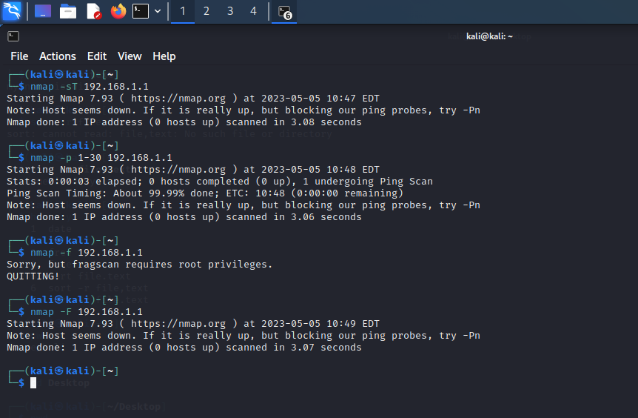

RESULT:

Hence the nmap scan performed successfully